

Urban Sustainability for the Twenty-four Hour City

Development of design decision-making tools & resources

Sheffield Case Study

Devonshire Quarter, City Centre, Sheffield

Understanding the urban design decision-making process for the development of the Devonshire Quarter

Dr. Christopher Boyko
WP1: Mapping the Urban Design Decision-making Process
6 February 2006

Table of Contents

1 Introduction
2 Background
2.1 Sheffield
2.2 Devonshire Quarter
2.2.1 Division Street/Devonshire Street/West Street Corridor
2.2.2 Broomsprings/Gell Street
2.2.3 Wellington Street/Charter Row
2.2.4 Milton Street/Egerton Street

2.3 Unitary Development Plan
2.4 Sheffield Development Framework
2.4.1 Local Development Scheme and Supplementary Planning
Documents
2.4.2 Core Strategy
2.4.3 City Policies
2.4.4 City Sites
2.4.5 Proposals Map
2.4.6 Statement of Community Involvement
2.4.7 Annual Monitoring Report
2.4.8 Area Action Plans- the Devonshire Quarter Action Plan
2.4.8.1 Development initiatives
2.4.8.2 Physical enhancements/Transport and access
2.4.8.3 Supplementary Planning Guidance
2.4.8.4 Management and maintenance

2.5 Sheffield Urban Design Compendium
2.5.1 Urban Design Compendium- Devonshire Quarter
2.5.1.1 Information about the Devonshire Quarter
2.5.1.2 Vision for the Devonshire Quarter
2.5.1.3 Principles for the Devonshire Quarter

2.6 Sheffield City Centre Masterplan
2.7 Sheffield City Council
2.7.1 Planning and City Development

2.8 Sheffield One
2.9 Devonshire Quarter Association
3 Methodology
4 Timeline for the Devonshire Quarter
5 The urban design decision-making process for the Devonshire Quarter
5.1 The Decision to Keep Devonshire Green an Open Space
and to Create an Urban Park on the Land
5.1.1 Decision-makers
5.1.2 Tools and Resources
5.1.3 Stakeholders
5.1.4 Sustainability

5.2 The Decision to Allow Inner City Housing Grants to Fund
Housing in Devonshire Quarter
5.2.1 Decision-makers
5.2.2 Tools and Resources
5.2.3 Stakeholders
5.2.4 Sustainability

5.3 The Decision to Open the Forum
5.3.1 Decision-makers
5.3.2 Tools and Resources
5.3.3 Stakeholders
5.3.4 Sustainability

5.4 The Decision to Design and Build West One
5.4.1 Decision-makers
5.4.2 Tools and Resources
5.4.3 Stakeholders
5.4.4 Sustainability

5.5 The Decision to Create the Devonshire Quarter
Association
5.5.1 Decision-makers
5.5.2 Tools and Resources
5.5.3 Stakeholders
5.5.4 Sustainability

5.6 Decision-Makers, Tools and Resources, Stakeholders and
Sustainability for the Devonshire Quarter as a Whole
5.6.1 Decision-Makers
5.6.2 Tools and Resources
5.6.2.1 Urban Design Compendium
5.6.2.2 Devonshire Quarter Action Plan
5.6.2.3 Devonshire Quarter Association
5.6.2.4 Sheffield One

5.6.3 Stakeholders
5.6.4 Sustainability

6 Conclusions
7 References
7.1 Interviews

8 Appendix
Figures

2.1 Aerial view of the Devonshire Quarter
2.2 Map of the Devonshire Quarter
2.3 View down Division Street, from Carver Street,
Devonshire Quarter
2.4 Aberdeen Court, Division Street, Devonshire Quarter
2.5 Corner of Division Street and Westfield Terrace,
Devonshire Quarter
2.6 View down West Street, Devonshire Quarter
2.7 Springfield School on Cavendish Street, Devonshire
Quarter
2.8 View of Broomsprings from the end of Cavendish Street,
Devonshire Quarter
2.9 View of Fitzwilliam Street from West Street. West One is
the large development on the right-hand side
2.10 West One, Devonshire Quarter

5.1 The urban design decision-making process for the
Devonshire Quarter, Sheffield.
1 Introduction

Sheffield has been experiencing somewhat of a renaissance lately. Since the collapse of the steel and coal mining industries in the 1970s and 1980s, the city is in a state of economic recovery, slowly transforming itself into a vibrant, liveable environment. One side effect of the economic recovery has been the improvement of old industrial areas around the city, which has had public support at the city centre level. Improvement of the city centre has taken the form of good quality public spaces, new recreational facilities, small pocket parks and access to rivers (Senior Council Officer, 8th June 2005). The Devonshire Quarter is the star of the city centre, boasting a large amount of these improvements, including urban green space, independent retail, mixed-use and mixed-tenure housing and meetings spaces for youth. This case study highlights the Devonshire Quarter as an exemplar of city centre living, working and recreating, in essence, a sustainable community.

The following report is divided into seven sections, with the Introduction being the first section. The second section briefs the reader on the background to the report, including information about the city of Sheffield, the Devonshire Quarter, some of the key decision-makers and stakeholders and some of the main documents prepared – or currently being prepared – by the city that impact the city centre and sustainability. The third section outlines the methods used to obtain information for this case study. The fourth section provides a timeline for the Devonshire Quarter, delineating the various “goings-on” in the area from the 1980s until the present day. The fifth section details the urban design decision-making process, taken from the timeline. Discussions about decision-makers, stakeholders, tools and resources and sustainability occur in this section. The sixth section summarises the case study in the Conclusions. The final section gives the reader the references used to prepare this case study.

2 Background

2.1 SHEFFIELD

Sheffield is the fourth largest city in England. Situated within the Yorkshire and the Humber region with Leeds as the regional capital, Sheffield has become an important sub-regional centre. Once known as the Socialist Republic of South Yorkshire and a staunch opponent of central government, Sheffield has dealt with the annihilation of its traditional economic base by searching for new ways of sustaining itself (Lesley Mackay, 2005; Parkinson & Robson, 2000).

Sheffield’s modern history may be traced back to the industrial revolution, when the city’s geography and topography made for an ideal place for water-powered industries to grow. In addition to water, Sheffield was already known as an important centre for cutlery, steel production and mining. As a result of all the industry and trade in the area, Sheffield’s population swelled, from 31,000 in 1800 to 400,000 by 1900. During this time, the town gained the status of Parliamentary borough (1832), then municipal borough (1843) and finally city status in 1893 (Wikipedia, 2005).

The large population and heavy trade spelled success for Sheffield well into the 20th Century. After the Second World War, large parts of the city were cleared and new roads, including the Inner Ring Road, and buildings, like the Park Hill flats, constructed. However, the success of the previous years would catch up with the city. Technological improvements and economies of scale in steel production – by now the main economic driver for the city region along with coal production (Beattie, 1986) – meant the steel industry was facing decline by the 1970s. In the 1980s, miner’s strikes and steel mill closures created economic hardship for Sheffield that was not compensated by service sector growth (Parkinson & Robson, 2000; Wikipedia, 2005). Between 1979 and 1983, for example, it is estimated that Sheffield lost 50,000 jobs, thanks in no small part to the collapse of the world market for metal products (Ramsden et al., 2001, cited in Mackay, 2005).

In the late 1980s and throughout the 1990s, Sheffield underwent an extensive process of urban regeneration, affecting many aspects of the city centre. The demolition of the Broomhall Flats in 1988 marked a turning point in the redevelopment of city centre land for mixed-tenure housing schemes (Sheffield City Council, 2004a). In 1990, the Meadowhall shopping centre was built outside the city, yielding a double-edged sword: the creation of much-needed jobs, but the acceleration of city centre decline. The 1991 World Student Games and the construction of the tram in 1992 helped to bring a positive spotlight back to Sheffield (Wikipedia, 2005). In the latter half of the 1990s, there was a major growth in student accommodation, with most new housing occurring in the Devonshire Quarter, Cultural Industries Quarter and Castlegate Quarter (student accommodation was discouraged in the western suburbs). The housing and students (over 45,000 students from two universities and several area colleges), had a major impact on the city centre population and local economy, supporting shopping, cafés, clubs and bars (Sheffield City Council, 2004a).

In the first decade of the 21st Century, more urban regeneration projects and ideas have flourished. In 2000, Sheffield One, one of three pilot Urban Regeneration Companies (URCs), began coordinating the various existing regeneration projects in the city through a joined-up partnership between the local, regional and national governments. New developments, such as West One in the Devonshire Quarter, also were built with an eye towards mixed-use. And Sheffield City Council has been swift to incorporate the national government’s advice on city centre living, urban design and sustainable communities, by creating a City Centre Living Strategy and the Urban Design Compendium, both in 2004.

Today, Sheffield’s population is approximately 513,000, with ethnic minorities composing less than 9.0% of that population (National Statistics, 2005, as cited in Mackay, 2005). Unemployment is around 6.4%, just above the national average of 5.0% (National Statistics, 2005, as cited in Mackay, 2005). Literacy and basic reading and writing skills are also just above the national average in the central ward of Sheffield (National Statistics, 2005, as cited in Mackay, 2005). According to Sheffield One (2004, as cited in Mackay, 2005), “there are deep-rooted problems in the city including social exclusion, deprivation and unemployment.”

2.2 DEVONSHIRE QUARTER

The Devonshire Quarter sits in the west part of the city, on the southern slopes of the high ridge separating the Don and Sheaf Valleys (see Figure 2.1 and 2.2). Its location allows good views of the surrounding country to the north and the south (Sheffield City Council, 2004b).

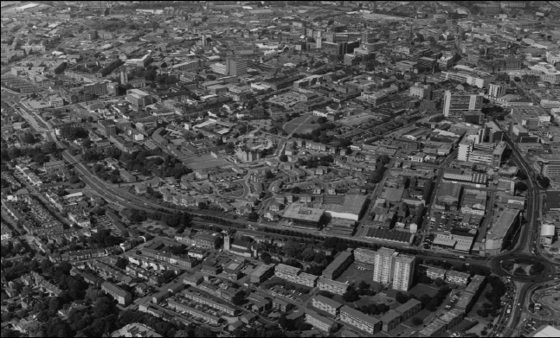
Figure 2.1. Aerial view of the Devonshire Quarter. Source: Devonshire Quarter Action Plan (2000).

The Devonshire Quarter was largely agricultural land until the beginning of the 19th Century. Owing to its remoteness from river valleys, the water-powered industry could not operate here. The railways also bypassed the area. With the advent of steam power, however, the area developed quickly in grid-like form, with a dense mix of three-storey terraced housing, factories, workshops, pubs, shops and places of worship (Sheffield City Council, 2000a, 2004b). Many of the factories and workshops were domestic in scale and light in trade. Instead of steel and heavy engineering – which relied on the railways and water to function properly – trades such as cutlery, hollowware and tool manufacture flourished (Sheffield City Council, 2000a).

Throughout much of the 1920s to the 1970s, slum clearance occurred in Sheffield, resulting in the demolition of much of the terraced housing in the Devonshire Quarter (Sheffield City Council, 2000a, 2004b). The decline of the light trades in the area from the 1950s also saw some of the cutlery factories and workshops cleared. After WWII, Sheffield adopted a Comprehensive Redevelopment Plan for the city centre, with particular attention paid to the area between Cambridge Street and Upper Hanover Street. This plan unwittingly intensified the blight and decline within the Devonshire Quarter. One example is the construction of the Broomhill Flats on Broomspring Lane in 1968. The heavy concrete housing was flawed from the start and proved unpopular, leading to its demolition just 20 years later (Sheffield City Council, 2000a).

The Comprehensive Redevelopment Plan was discarded around 1981. The Council decided to offer improvement grants for commercial buildings in the Wellington Street and Devonshire Street areas as a way to encourage regeneration. In 1980, for example, workshop units on Wellington Street and Eldon Street were built and have remained popular (Sheffield City Council, 2000a).

Also in 1981, Devonshire Green rose from the collective ashes of temporary car parks and was made into a park by the Council. With the Green completed, the character of the Devonshire Quarter changed. The first Housing Association accommodations on Devonshire Street were built and specialist shops and bars were dotted around the area in the 1980s. Growth was slow, however (Sheffield City Council, 2000a).

In the 1990s, things began to improve in the Devonshire Quarter. Broomhall Flats was successfully redeveloped in 1991 with mixed tenure houses and flats for sale and for rent. In the same year, the Forum café bar and shopping arcade opened. Shops in the Forum were rented inexpensively to independent retailers, which has encouraged the growth of Division Street as a niche area with independent shops and cafés (Sheffield City Council, 2000a, 2004b; Devonshire Quarter business owner, 14th June, 2005).

More improvements followed. The University of Sheffield and Sheffield Hallam University both committed themselves in the mid-1990s to direct new build student accommodation towards the city centre, which has impacted the growth of the Devonshire Quarter. A new trend was also developing in the form of a rekindled interest in city centre living. The Council carried out research in 1998, showing that 12% of their sample felt unsatisfied by the lack of housing in the city centre, including the Devonshire Quarter. In response, the Council have devised new approaches to accommodation within the city centre, such as creating “carless” housing and paying special attention to environmental issues (e.g., noise). Sheffield One has also lent support to new and innovative housing schemes, as they focus on urban regeneration projects in the Devonshire Quarter that attempt to connect new retail, housing and late-night entertainment within the area (Sheffield City Council, 2000a).

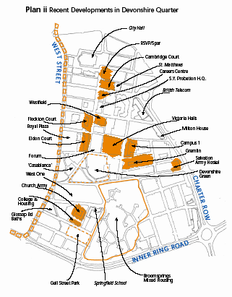
Figure 2.2. Map of the Devonshire Quarter.
Source: Devonshire Quarter Action Plan (2000).

Within the Devonshire Quarter, four areas have been designated, each with different physical and economic characteristics. These areas are:

- Division Street/Devonshire Street/West Street Corridor.
- Broomsprings/Gell Street.
- Wellington Street/Charter Row.
- Milton Street/Egerton Street (Sheffield City Council, 2000a).

2.2.1 Division Street/Devonshire Street/West Street Corridor

The morphology of the area between West Street and Wellington Street is grid-like. Together with Glossop Road, this area contains most of the retail activity – including many independent shops in comparison to the High Street – and much of the bars, pubs, clubs and restaurants in the Devonshire Quarter. Development of retail within the area has benefited from small, less expensive premises, such as the Forum, Aberdeen Works and Alpha House, which have created “nursery units” for new retail concepts (see Figures 2.3-2.6) (Sheffield City Council, 2000a).

In addition to retail and entertainment, this area benefits from small manufacturing businesses, an important office sector and voluntary organisations. Resident accommodation also comprises a significant proportion of building space in the area. Over 1000 people live in the area, in places such as Victoria Hall (student accommodation), the Old Fire Station (Sheffield City Council, 2000a) and Royal Plaza (Sheffield City Council, 2004b).

The mixed-use feel of the area may have contributed to some problems. There is concern over noise and behaviour issues associated with late-night bars and clubs. Fear of crime, poor lighting, street begging and a substandard quality streetscape are other issues within the area (Sheffield City Council, 2000a).

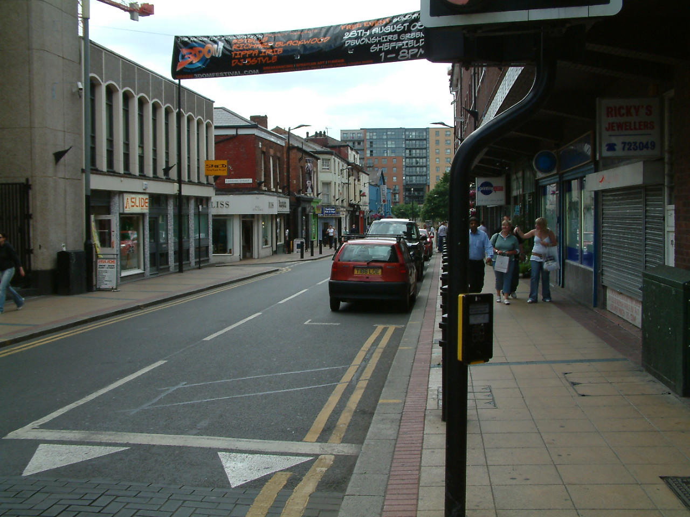
Figure 2.3. View down Division Street, from Carver Street, Devonshire Quarter.

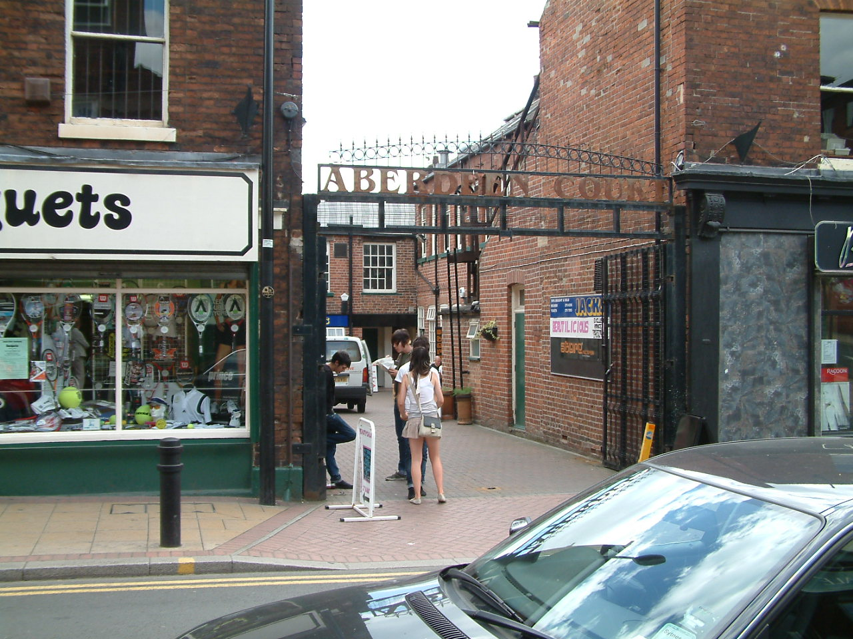
Figure 2.4. Aberdeen Court, Division Street, Devonshire Quarter.

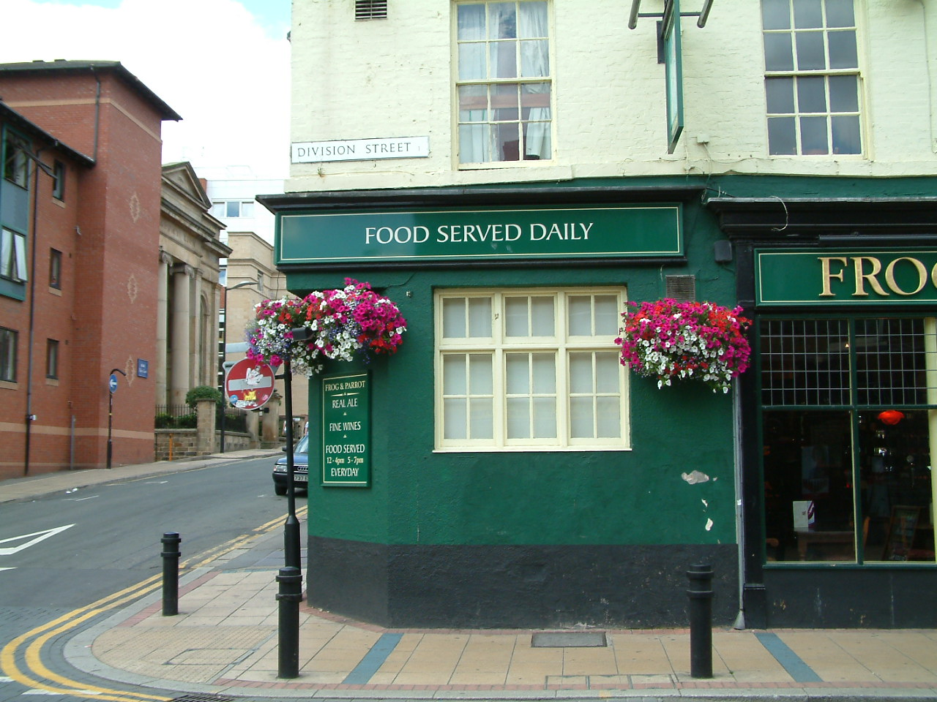
Figure 2.5. Corner of Division Street and Westfield Terrace, Devonshire Quarter.

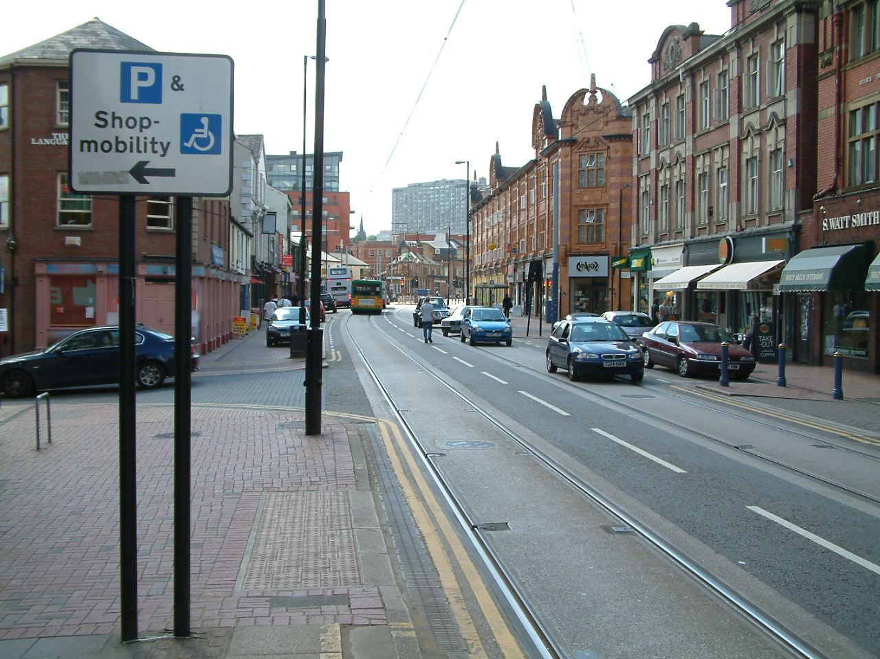
Figure 2.6. View down West Street, Devonshire Quarter.

2.2.2 Broomsprings/Gell Street

Much of this area is residential, with a population of about 1000 in 1998. New developments, particularly on Fitzwilliam Street (West One), Glossop Road and Cavendish Street, help to increase this diverse population (see Figures 2.7-2.10) (Sheffield City Council, 2000a). Projects like West One, and Royal Plaza on West Street, should help to “encourage economic growth and set a new standard for residential developments aimed at attracting and retaining long-term residents” (Sheffield City Council, 2004b, p. 129).

Residents and businesses would like to maintain the diversity of income groups, ages and lifestyles within the area, so efforts are being made to procure dedicated community facilities. These facilities would also help to decrease drug dealing, vandalism and the lack of things to do for teenagers in the area (Sheffield City Council, 2000a).

Between Gell Street and Victoria Street, a “pocket park” exists, with a playground, basketball and football pitches. The area also benefits from Springfield Junior and Infants School, intermingled with terraced and detached houses with gardens (Sheffield City Council, 2000a).

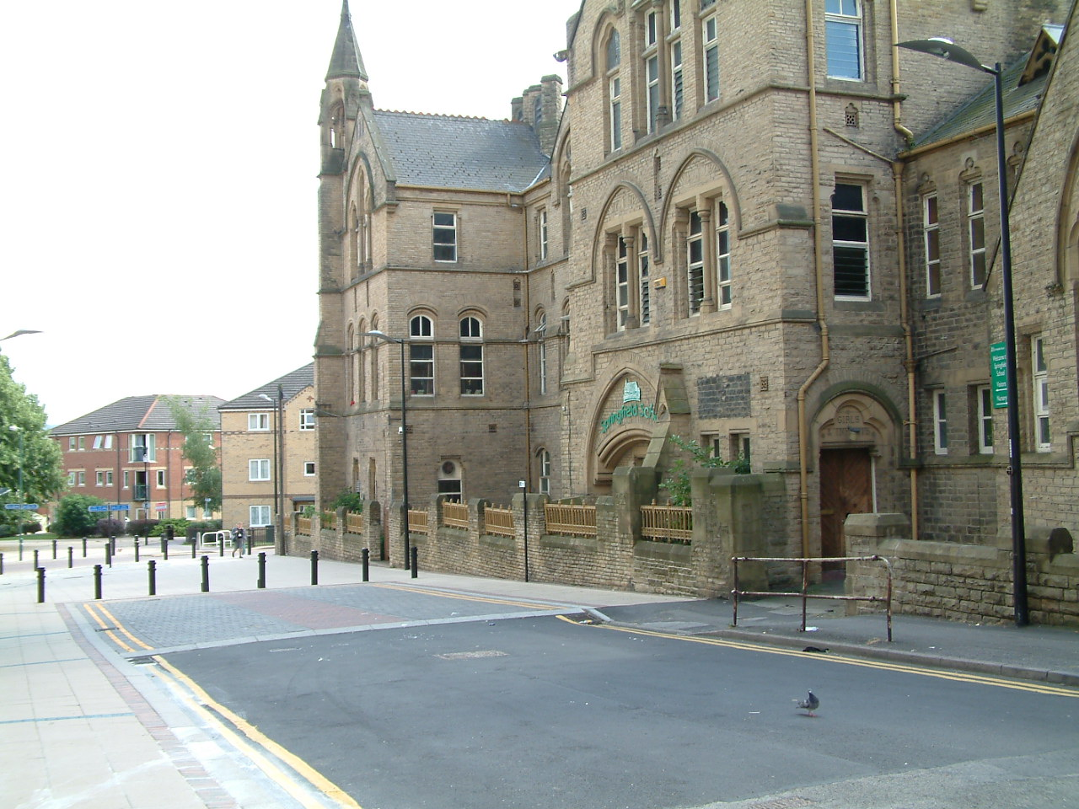
Figure 2.7. Springfield School on Cavendish Street, Devonshire Quarter.

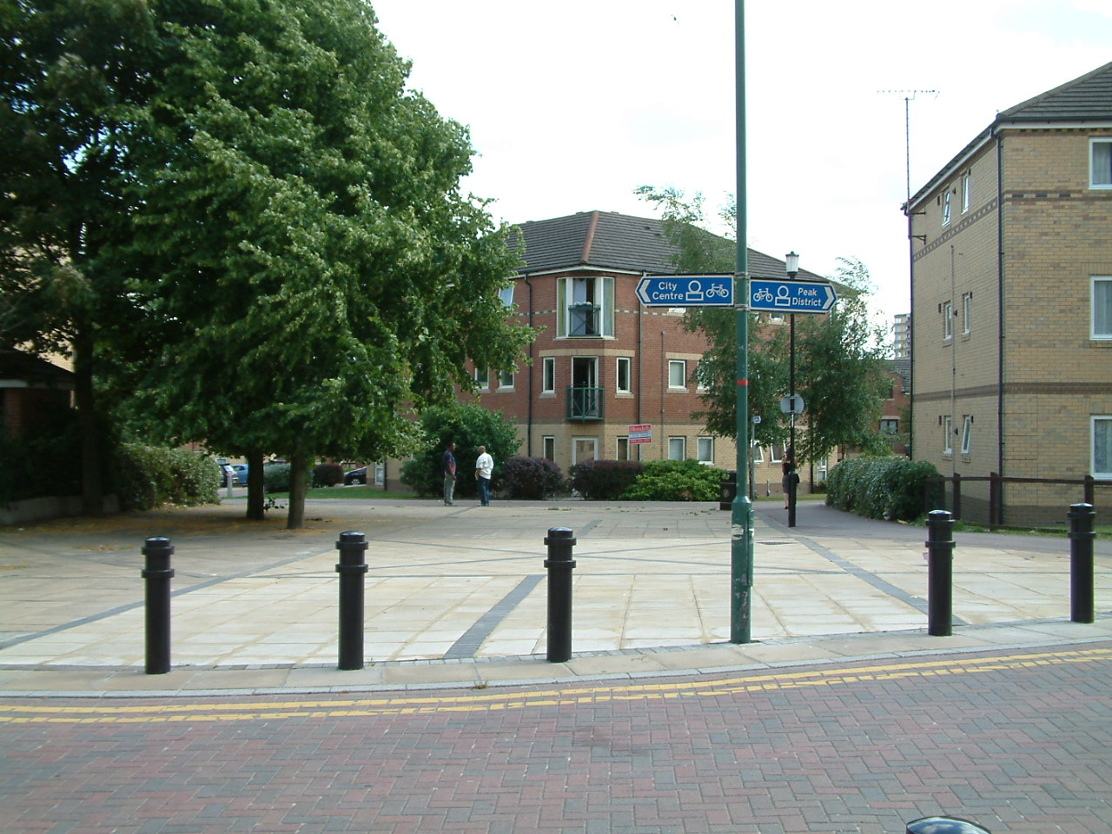
Figure 2.8. View of Broomsprings from the end of Cavendish Street, Devonshire Quarter.

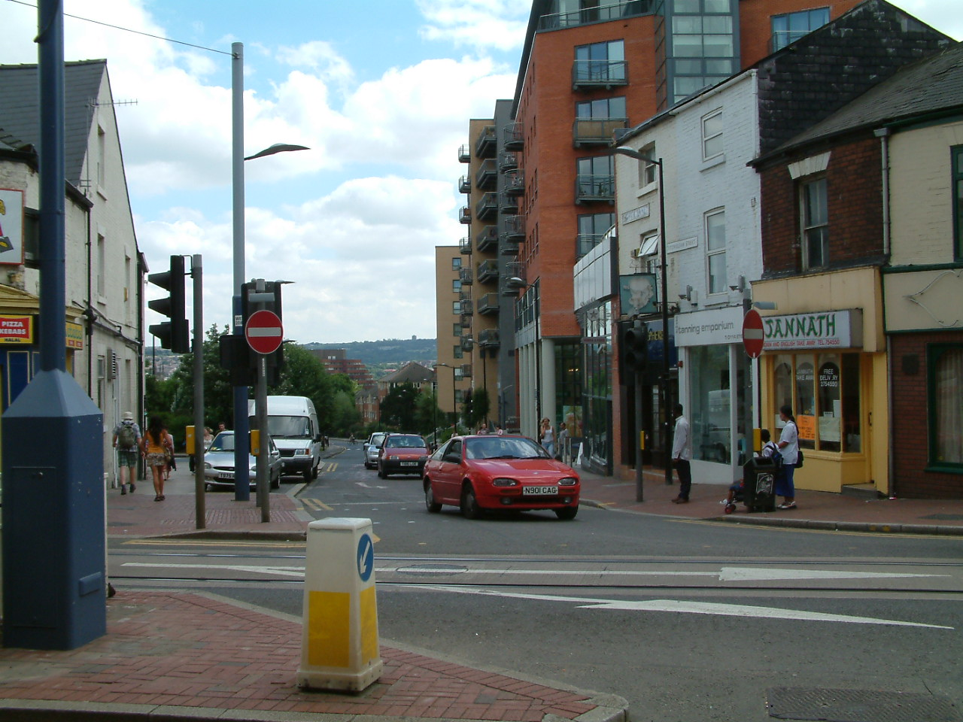
Figure 2.9. View of Fitzwilliam Street from West Street. West One is the large development on the right-hand side.

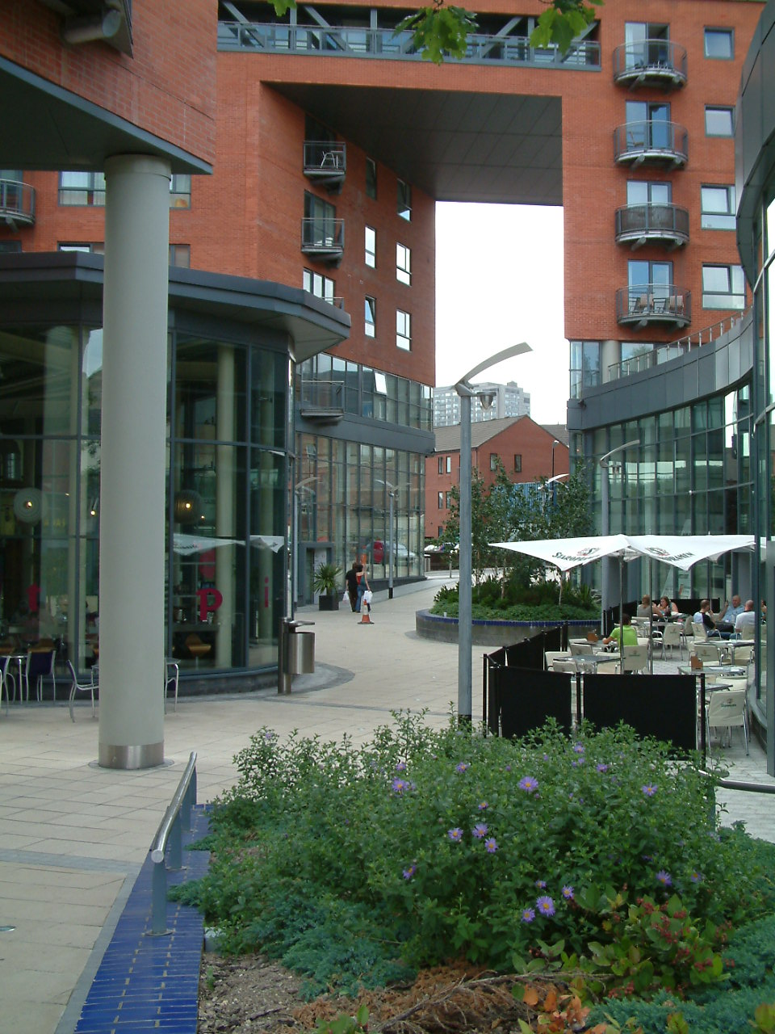
Figure 2.10. West One, Devonshire Quarter.

2.2.3 Wellington Street/Charter Row

This area is dominated by 1960s office blocks – Milton House, Chesham House and Telephone House – along Charter Row. Part of this block includes a multi-storey car park, a restaurant and a nightclub, and is connected by a skyway. The remaining part of this area consists of principally 20th Century industrial and warehouse buildings with a mix of uses, including artist studios. The streets along Charter Row include subways, which are perceived to be unsafe, unattractive and poorly lit (Sheffield City Council, 2000a).

2.2.4 Milton Street/Egerton Street

This area is largely industrial, focusing on metalwork, cutlery, fabrication and engineering. Buildings, such as the Beehive and the Eye Witness Works, lend the area some character. Small terrace housing in multiple occupation provides some distinction to the industrial buildings, as does a former school, a training centre and retail premises. One source of concern in the area is the impact of controlled parking. Some people would like firms without off-street parking to have a parking scheme similar to residents (Sheffield City Council, 2000a).

The following subsection examines some of the major policies that influence the Devonshire Quarter. These policies include the Unitary Development Plan, the Sheffield Development Framework, the Sheffield Urban Design Compendium and the Sheffield City Centre Masterplan.

2.3 UNITARY DEVELOPMENT PLAN

The Unitary Development Plan (UDP) was adopted in March 1998 as a 10-year plan for Sheffield, “A City for People”. Four principle aims emerged from this document:

- To make a better environment.
- To create a more thriving community.
- To improve accessibility to all parts of the city.
- To make a more caring environment (Sheffield City Council, 1998).

The UDP was not intended to be a plan solely for developers, but provided for people living, working, visiting and using developments in the city. An extensive 6-month public consultation ensured that many stakeholders were consulted during the process of creating the UDP (Sheffield City Council, 1998).

Within the UDP, it was suggested that the city be divided up into quarters, an idea first proposed by one of the Forum owners (Devonshire Quarter business owner, 14th June, 2005). Within the Devonshire Quarter, four areas were identified that roughly correspond to the areas mentioned in the Devonshire Quarter Action Plan. These areas are designated for the following:

- A business area.
- A fringe industry and business area.
- A housing area, with part of the quarter zoned as a central shopping area with a City Centre Housing Priority Zone.
- An Area of Special Character.
- Part of the City Centre Conservation Area (Sheffield City Council, 2004b).

Additional policies within the UDP that are of relevance to the Devonshire Quarter include a policy concerning access and parking and a policy regarding environmental and open spaces (Sheffield City Council, 1998).

2.4 SHEFFIELD DEVELOPMENT FRAMEWORK

With the adoption of the Planning and Compulsory Purchase Act 2004, national government, under the Office of the Deputy Prime Minister, has revised the planning system. The new system requires that a local development framework (LDF) be created, containing a portfolio of local development documents (LDD). These documents provide the spatial planning strategy for the local authority’s area (HMSO, 2004; ODPM, 2003). In most cases, the LDF builds upon the existing UDP, which continues to form the statutory development plan while the LDF is being prepared. Once the LDF is in place and adopted, the LDD will replace some of the UDP policies (Sheffield City Council, 2005a).

The documents within Sheffield’s LDF, called the Sheffield Development Framework (SDF), include:

- A Local Development Scheme.
- Core Strategy.
- City Policies.
- City Sites.
- Proposals map.
- Statement of Community Involvement.
- Annual Monitoring Report.
- Supplementary Planning Documents.
- Area Action Plans, among them, the Devonshire Quarter Action Plan (Sheffield City Council, 2005a).

2.4.1 Local Development Scheme and Supplementary Planning Documents

The Local Development Scheme (LDS) indicates which documents will be prepared for the future and when opportunities will arise for contribution by various organisations and individuals. The LDS contains two types of documents:

- Development Plan Documents (DPDs), which carry statutory weight and are subject to independent examination and community involvement. DPDs must conform to the Regional Spatial Strategy, prepared by the Regional Development Agency.
- Supplementary Planning Documents (SPDs), which are non-statutory and do not involve independent examination. Nonetheless, community engagement is required (Sheffield City Council, 2005a).

Together the Regional Spatial Strategy and the DPDs comprise the Development Plan for each area, which will eventually replace the UDP. In Sheffield, the Local Development Scheme was submitted and published in March 2005. The remaining documents are currently being written or will be written and published within the next 5 years (Sheffield City Council, 2005a).

2.4.2 Core Strategy

The purpose of the Core Strategy is to provide the aims and overall strategy for an area, create linkages with other strategies (e.g., Regional Spatial Strategy, Housing Market Renewal Pathfinder, Local Transport Plan), identify the major spatial changes that will take place over 15 years, introduce different policy areas and set out locational criteria when spatial criteria is not specific enough (Sheffield City Council, 2005a).

2.4.3 City Policies

These policies will serve as a guide for land-use regulation and design. They will set out the preferred and acceptable uses within policy areas, supply generic criteria to support planning guidance and decisions, include additional policies used in the creation of masterplans and planning briefs and the determination of planning applications, and guide new proposals in achieving sustainable development (Sheffield City Council, 2005a).

Each City Policy should have a section on the environment, which may be broken down into urban design, built heritage and natural resources. It is here that sustainable development is specifically mentioned, taking the form of protecting and enhancing the city’s natural resources and securing environmentally sustainable development (Sheffield City Council, 2005a).

2.4.4 City Sites

The purpose of City Sites is to indicate specific land allocations and site-specific proposals. These sites may be added to or deleted from the Proposals Map as new sites are developed and identified. Land allocations that Sheffield City Council may be examining in the SDF include business and industry, shopping and leisure, schools, housing, proposed open spaces, waste management and transport (Sheffield City Council, 2005a).

2.4.5 Proposals Map

The Proposals Map gives the spatial dimension for policies and proposals within DPDs. The Map will indicate specific policy-area boundaries (e.g., Green Belt), areas within other areas where specific policies apply (e.g., Conservation Areas), transport features and allocated sites (Sheffield City Council, 2005a).

2.4.6 Statement of Community Involvement

The Statement of Community Involvement indicates who would like to be involved in document preparation, which documents will be prepared, when they can become involved and how they can participate in the process. The Statement will also specify the process by which communities can provide feedback on planning applications (Sheffield City Council, 2005a).

2.4.7 Annual Monitoring Report

At the end of the calendar year, an Annual Monitoring Report will be prepared that will record progress in preparation of the SDF and implementation of SDF policies and proposals (Sheffield City Council, 2005a).

In addition to the Annual Monitoring Report, a Sustainability Appraisal Report of all SDF documents is required. The Sustainability Appraisal Report will be issued at successive stages of SDF document preparation, and is needed to satisfy the statutory requirement of achieving sustainable development. The Report incorporates the Strategic Environmental Assessment, required by European Law, and provides a thorough framework for weighing environmental, social and economic issues in both the short-term and long-term (Sheffield City Council, 2005a).

2.4.8 Area Action Plans- the Devonshire Quarter Action Plan

The Devonshire Quarter Action Plan describes a vision of the Devonshire Quarter over 10 years, starting in 2000. The vision is mainly private and voluntary sector-led. In some cases, though, involvement will be Council-led through incentives and the encouragement of community action (Sheffield City Council, 2000a).

The initial programme consists of development initiatives, physical enhancements, transport and access, supplementary planning guidance and management and maintenance.

2.4.8.1 Development initiatives

These initiatives consist of Council- and partner-led actions to promote the development market in places of need. For example, through the use of Compulsory Purchase Orders, the Council and Sheffield One may acquire key parcels of land for regeneration purposes. The Council may also encourage owners of vacant sites in regeneration areas to develop in accordance with the Devonshire Quarter Action Plan. Creating resources to help local people become more active in regeneration schemes, via secondments, bids to Single Regeneration Budgets and Objective 1 funding, is yet another way to support development in areas where the market does not appear to be functioning (Sheffield City Council, 2000a).

2.4.8.2 Physical enhancements/Transport and access

Enhancements can be made to main streets, public spaces and the accessibility of various routes within and around the Devonshire Quarter using known sources of funding through Section 106 contributions, Single Regeneration Budgets and the Local Transport Plan. Planning conditions and agreements can also help improve walkways, lighting and landscapes (Sheffield City Council, 2000a).

2.4.8.3 Supplementary Planning Guidance

The Devonshire Quarter Action Plan sets out three new proposals for Supplementary Planning Guidance, which, if approved, will elaborate on the policies of the Unitary Development Plan and the soon-to-be Local Development Framework. The first proposal seeks to protect the special character of retail in the area:

The intention of the policy is to protect the continuity of existing specialist shopping from further dilution by non-shopping uses and to support the revival of specialist shopping on West St/Glossop Rd./and the connecting streets Rockingham St and Westfield Terrace (Sheffield City Council, 2000a, p. 59).

Thus, ground floor shop frontages with A2 (financial and professional services) and A3 (restaurants and cafés) use will be limited to one third of any block on Division Street and Devonshire Street and Carver Street between Division Street and West Street. On West Street/Glossop Road between Carver Street and Upper Hanover Street, on Westfield Terrace and on Rockingham Street from Division Street to West Street, one half of ground floor frontage of any block will be permitted to change to A2 and A3 use. Currently, the proportion of shopping to other retail on Division Street and Devonshire Street is 2:1, whereas the proportion is about 1:1 on West Street and Glossop Road (Sheffield City Council, 2000a).

The second proposal seeks to restrict new D2 (assembly and leisure, including dance and bingo halls, casinos, cinemas and gymnasia) uses in the Housing Priority Zone:

The creation of new nightclubs (i.e., D2 Uses with extended late opening hours) either by extending pub/bar (A3) operations or by new development will not be permitted in the City Centre Housing Priority Zone in order [sic] to protect night time living conditions for residents (Sheffield City Council, 2000a, p. 59).

This proposal is part of an existing UDP policy that prefers the development of new, sustainable communities in places that are free from substandard living conditions. According to the Council, what facilitates substandard living conditions is the growth of late-night entertainment “in close proximity [of the City Centre Housing Priority Zone], creating late night crowds of boisterous revellers, noise and disorder associated with hot-food vans and taxis” (Sheffield City Council, 2000a, p. 60).

The third proposal seeks to retain a housing mix within the City Centre Housing Priority Zone:

…a balanced mix of housing types – family, childless singles/couples and student – including a proportion of affordable units to rent and buy will be required in new housing development of twenty or more units (Sheffield City Council, 2000a, p. 60).

In accordance with UDP Policy, this proposal necessitates strengthening existing communities and retaining a balance of different resident types in roughly equal proportions (Sheffield City Council, 2000a).

2.4.8.4 Management and maintenance

The Council is proposing to create better signage, traffic routes, organisation of cleaning, landscape care, and improve security. They have already created a new City Manager’s Office and City Centre Ambassador service. The Devonshire Quarter Association also may help to promote co-operation between the different sectors within the area, including residents, businesses and the voluntary sector (Sheffield City Council, 2000a).

2.5 SHEFFIELD URBAN DESIGN COMPENDIUM

The Urban Design Compendium was produced in 2004 through a partnership with Sheffield City Council, Sheffield One, CABE, English Heritage and Yorkshire Forward. The Urban Design and Conservation team within Sheffield City Council’s Planning and City Development were in charge of writing the Compendium (Senior Design Officer, 30th June, 2005). Building on national urban design guidance, government strategy, policy statements and best practice advice, the focus of the Compendium is on the design of the city’s built form and public realm. Six over-arching themes guide the Compendium to the “repair and reinvention of Sheffield city centre and achieve long-term sustainability for the city” (Sheffield City Council, 2004b):

- Identity and diversification- promoting Sheffield’s culture, creativity and knowledge economy as well compatible and diverse land uses that will enhance the city’s character. Having a diversity of housing tenures within the city centre will help repopulate the area and sustain a safe evening economy.
- Respect of existing, and creation of new, character areas- encouraging development that responds to the distinctiveness of Sheffield’s Quarters via contemporary, positive and innovative design.
- Integrated movement network- improving connectivity and permeability with an integrated pedestrian, vehicular, cycling and public transport network. The network will contribute to a more socially inclusive city and a greater reliance on sustainable transport.
- Robust built form- showing innovation and adaptation in design for both new and existing structures and sites, offering continuity and legibility.
- Sense of place- establishing safe, attractive, inclusive and functional environments for public realm activity through simple streetscape design.
- Implementation- broadening the range of stakeholder input on design and involving the public in the design process, from the design brief stage to maintenance. Marketing and promotion is another way that Sheffield can promote quality design as part of a strategy to (re)form a city identity (Sheffield City Council, 2004b).

Each of the Quarters within Sheffield City Centre is discussed in the Compendium, including the Devonshire Quarter.

2.5.1 Urban Design Compendium- Devonshire Quarter

The section of the Compendium relating to the Devonshire Quarter contains information about the Quarter, as well as a Vision and Principles to help guide development.

2.5.1.1 Information about the Devonshire Quarter

According to the Compendium, the Devonshire Quarter has several areas with distinct character. These areas overlap somewhat with the areas mentioned within the UDP and the Devonshire Quarter Action Plan and include:

- St George’s- comprises St. George’s Church, Jessop Hospital and the Mappin Building.
- Wilkinson Street and Gell Street- mainly 19th Century residential buildings, most are private owned. This area retains a strong grid street layout and a specific industrial vernacular.
- Devonshire Green- the largest public park in the city centre.
- Holly Street/Cambridge Street to Westfield Terrace/Trafalgar Street- the area shows the dense, mixed industrial and residential use that characterised much of central Sheffield from the mid-19th Century to early-20th Century.
- Milton Street- two examples of metal trades structures exist on this street. The area also unfortunately hides an attractive group of Georgian and Victorian buildings behind walls (Sheffield City Council, 2004b).

Also within the Devonshire Quarter is the Headford Grove area, which comprises a 1980s housing development, complete with cul-de-sacs, winding roads, shared surfaces, cycling and pedestrian priority, soft landscaping, simple street furniture and a garden suburb feel (Sheffield City Council, 2004b). Although not an area of distinct character, Headford Grove provides quite a contrast to the rest of the Devonshire Quarter due to its suburban quality.

The quality of the public realm varies within the Devonshire Quarter. Division Street has seen improvements that attempt to strengthen the connection between the Quarter and the Heart of the City as well as the surroundings of West One and Royal Plaza. The mixed-use developments around Division Street have also become the focus of an “urban village” concept, extending towards the Heart of the City through to St. George’s Quarter. However, much of the public realm improvements do not take into account the surrounding side streets of the Quarter, which generally has asphalt roads, tarmac paving and ordinary street lighting (Sheffield City Council, 2004b).

2.5.1.2 Vision for the Devonshire Quarter

The Vision for the Devonshire Quarter sees the area developing as a vibrant, mixed-use “urban village” within the city centre. The idea will be encouraged via a “living over shops” scheme on main commercial streets and mixed tenure residential on secondary streets (Sheffield City Council, 2004b).

The Quarter will also become a renowned cultural entertainment destination, with independent retail, cafés, bars, restaurants and specialist music clubs to rival Temple Bar in Dublin. Division Street and West Street will support the city centre retail concept while lending a strong pedestrian focus to the area. The pedestrian focus will also reinforce the link with the University of Sheffield, St. George’s and St. Vincent’s (Sheffield City Council, 2004b).

Devonshire Green will continue to be a focal point for the Quarter and will be further developed to provide an attractive setting for festivals, markets and music events. The Milton Street industrial area will also become a desired location for the remaining industrial companies within Sheffield, creating a more cohesive industrial market (Sheffield City Council, 2004b).

2.5.1.3 Principles for the Devonshire Quarter

The following principles apply to the Devonshire Quarter, which will help guide development within the area:

- Degree of intervention- a programme of “repair and recovery” should be followed, which supports the existing “urban village” feel while incorporating new uses and opportunities.
- Architectural style and materials- architectural style will be innovative and contemporary. Existing buildings should provide adaptable space. Buildings should maintain a compact “urban village” appeal and enhance safety via natural surveillance of the street. Building materials should be sensitive to the area’s character and be sourced locally from sustainably managed resources.
- Building form and height- new developments should be innovative and contemporary, yet respect the scale and proportion of the existing built environment. Buildings should be between 2-5 storeys, reflecting existing structures, as well as enhancing West One, the Quarter’s landmark building.
- Public realm improvements and materials- improvements must extend to side streets to create more cohesion and make a more attractive environment. Dual function spaces, unique street lighting, multi-functional car parking and soft landscaping to the area’s urban parks are also encouraged (Sheffield City Council, 2004b).

2.6 SHEFFIELD CITY CENTRE MASTERPLAN

The masterplan was prepared by Koetter Kim and Associates in 2000, and commissioned by Sheffield One. The aim of the masterplan is to set out “a clear and unambiguous strategy for Sheffield to regain its status as one of Europe’s leading cities” (Sheffield City Council, 2000b). Four principle objectives lie at the heart of the masterplan:

- Building a new high technology-based economy.
- Creating a vibrant city for learning, culture, retail, business, recreation and living.
- Improving accessibility.
- Celebrating the public realm (Sheffield City Council, 2000b).

Koetter Kim’s plan acts as a framework to guide the revitalisation of the city centre over a 10-15 year period. The framework combines public sector involvement with private sector investment Sheffield City Council 2001, as cited in Mackay, 2005).

The next subsection considers some of the key decision-makers in Sheffield, the city centre and the Devonshire Quarter. These decision-makers include Sheffield City Council, Sheffield One and the Devonshire Quarter Association.

2.7 SHEFFIELD CITY COUNCIL

Sheffield had been a Labour stronghold throughout much of the 1980s and 1990s, with the baton being passed to the Liberal-Democrats from 1999-2002 and then back again to Labour. The change in government in the late-1990s and again in 2003 meant different approaches to regeneration, although there always seemed to be general agreement about the Vision for Sheffield city centre (Councillor, 2005, as cited in Mackay, 2005). The Chief Executive, Bob Kerslake, guides the Vision for regeneration and stands in good favour within his own political party (Councillor, 2005, as cited in Mackay, 2005). There are tensions, however, within the Labour party, mainly concentrated on criticisms of the management style of different councillors. The criticisms have effectively slowed the progress of regeneration in the city. Coupled with these criticisms are council officers’ new roles as proactive “agents of change.” Previously, officers took a safer, less innovative and reactive role to regeneration, which they do not find easy (Councillor, 2005, as cited in Mackay, 2005).

2.7.1 Planning and City Development

Within Sheffield City Council is Planning and City Development. Led by the Head of Planning, Les Sturch, and Head of City Development, Simon Ogden, the department aims to accomplish four goals:

- Regeneration of the city and its neighbourhoods in a sustainable manner.
- Raising design quality across Sheffield in the built and natural environments.
- Launching a new City Plan that will guide the future pattern of development.
- Modernising planning and development services associated with communities (Sheffield City Council, 2005b).

Planning and City Development may be further subdivided into Development Control, Forward and Area Planning, Environmental Planning, City Development Division and Urban Design and Conservation. Each of these departments is responsible in some way for the development of the city centre and their decisions impact the shape of the Devonshire Quarter.

2.8 SHEFFIELD ONE

In the Urban Task Force Report, Towards an Urban Renaissance, Lord Rogers recommended the creation of URCs to stimulate new investment in areas of economic decline. He also suggested that URCs could co-ordinate plans for regeneration and redevelopment in accordance with the objectives of a wider local strategy developed by local authority, development agencies, local community representatives, and even land owners. URCs would be most relevant in areas containing intensive regeneration projects.

Sheffield One was one of three pilot URCs created by government in 2000. The URC was created to lead the transformation of the city centre into an economic driver for growth across the whole region. To achieve this transformation, the URC needs to

…reconfigure the retail core and create a credible central business district, to improve the transport network and improve the ‘legibility’ of a city centre that has suffered in postwar years from having developed on a too-diffuse land use basis. In addition, it is recognised that Sheffield needs to be better connected to the remainder of South Yorkshire so that constituent districts might each gain from greater competitiveness in the conurbation core (Parkinson & Robson, 2000).

For the regeneration of Sheffield city centre to be supported, the Council needed to recognise the weaknesses that currently existed within the city centre and needed to work side-by-side with the private sector, fast-tracking some of the traditionally time-consuming government procedures. Sheffield One also needed to drive development proactively, rather than passively giving grants to the private sector in hopes that the private sector would respond positively.

The ambitious regeneration programme has already made the city a creative and cultural capital within Yorkshire. With £250 million of new development still to come, Sheffield is rapidly becoming one of the top business locations in the country. High profile schemes, including the Heart of the City, the New Retail Quarter, e-campus and Castlegate, are attracting major investment and new jobs, positioning Sheffield as a vibrant, cosmopolitan and successful city within Europe.

2.9 DEVONSHIRE QUARTER ASSOCIATION

The Devonshire Quarter Association was formed in 1998, and represents residents, business, voluntary organisations, students and other local organisations in the area. The Association Committee consists of four members from each of the following sectors: voluntary/community, private, residents and business plus an elected Sheffield City Councillor (Devonshire Quarter Association, 2001). In addition to these members, other groups or individuals have standing invitations to attend meetings, such as the Head Teacher at Springfield School and community officers (Devonshire Quarter resident, 15th July, 2005; Voluntary sector businessperson, 4th July 2005).

Association meetings take place approximately once a month in addition to an annual general meeting and special meetings, used for altering the constitution or to consider any matters of importance to the Quarter (Devonshire Quarter Association, 2001).

Through their constitution, the Association aims to:

- Protect and advance the interest of all sectors in the Devonshire Quarter regarding housing, business, the environment and social and community like.
- Encourage community spirit and eradicate discrimination.
- Promote the interests and rights of all sectors and groups.
- Ensure that all members are consulted regularly and that all sectors and groups are encouraged to join the Association.
- Improve facilities in the area.
- Help build a good relationship between residents and businesses (Devonshire Quarter Association, 2001).

3 Methodology

Information for this case study was gathered between April 2005 and August 2005 from the following sources:

- Interviews with members of Sheffield City Council; urban and regional regeneration specialists; a voluntary sector businessperson; a private sector developer, and; a business owner and manager, a resident and a retailer, all from the Devonshire Quarter.
- Minutes and reports from Sheffield City Council.
- Reports by VivaCity2020 colleagues on Sheffield.
- Local and national documents regarding planning policy and sustainability.

Nine interviews were completed with 11 interviewees for this case study. Interviews lasted on average between 1 and 1 ½ hours. In four instances, more than one interviewer was present for the interview, with the remaining interviews conducted by one interviewer. For each semi-structured interview, interviewees were asked to elaborate on the following concepts (see Appendix for larger set of questions):

- The urban design process for the Devonshire Quarter from its conception until the present day.
- Urban design decisions that were made and who made those decisions.
- The methods, tools and techniques used by decision-makers when making decisions.
- Who are/were the stakeholders in the urban design process.
- The major issues (e.g., sustainability) to be tackled in the urban design process.

In all instances, the interviews were audio recorded and summaries were made soon after the interviews. The audio recordings were also transcribed in full by a transcriber.

All of the information from the case study was analysed using content analysis. Coding was done by hand; data management software (e.g., Nud*ist) was not used. Codes in the form of words and phrases were used to describe a relevant emergent theme or category of activity or thought.

4 Timeline for the Devonshire Quarter

The following section details the timeline for the Devonshire Quarter. Significant people, places and years are presented in chronological order, beginning in 1981 and ending in the present day.

1981: Devonshire Green is created along with two or three other urban parks, including Gell Street Park. The parks are funded through the Urban Programme of the 1980s (Urban regeneration specialist, 7th April 2005; Senior Council Officer, 8th June 2005). The layout of Devonshire Green is simple and is quite unique at the time because there are no other green spaces of that size in the city centre (Senior Council Officer, 8th June 2005). Devonshire Green is used mainly by young people, but also by local residents walking their dogs or wanting a place to eat outdoors. The weekends and summer evenings are particularly busy times (Senior Council Officer, 8th June 2005).

Devonshire Green was originally a churchyard and an inner courtyard for a 1930s semi-private flat development. The area was heavily damaged after World War II and transformed into a series of car parks (Senior Council Officer, 8th June 2005; Senior Cabinet member, 31st August 2005). The car parks were an amenity for the Broomhall Flats, built in 1968. In 1981, there is a struggle between Sheffield’s Planning Department and the City Estates Department over Devonshire Green; the latter want to build factory units on the open space (Senior Council Officer, 8th June 2005). Sheffield City Council decides to keep the Green as open space, which serves as a catalyst for growth in the area (Senior Cabinet member, 31st August 2005).

Mid-to-late 1980s: Housing Association grants for dwellings on Devonshire Street are permitted. These grants plant the seeds for the idea of a mixed-tenure area. Concomitantly, student accommodation is offered, which gives way to new apartments for students and, finally, apartments for sale. All of this occurs without public sector input (Urban regeneration specialist, 7th April 2005).

1988: Broomhall Flats are demolished. Tesco supermarket has an interest in the 5 hectare site. Sheffield City Council decides to promote housing in the area instead, even though they could receive a lot of money from Tesco for that site. This is considered a brave step because no one has built housing for sale in the city centre in the 20th century (with the exception of the housing grant schemes of the mid-to-late 1980s). Local estate agents believe that there is no interest in city centre living at this time, so building a new scheme is a waste of resources (Senior Council Officer, 8th June 2005; Urban regeneration specialist, 7th April 2005).

1990: The Forum, a restaurant/café/terrace/indoor shopping mall/youth hangout, is purchased (Devonshire Quarter business owner, 14th June 2005). In its original form, however, the Forum contains only shops and a tiny café (Devonshire Quarter resident, 15th July 2005). The owners of the Forum choose the site because of the good location between the city centre and the University of Sheffield and the Georgian character of the buildings. The idea of renovating the Forum buildings, which used to be bathroom and window glazing shops and had been vacant for some time, proves too tempting to resist for the owners. The Forum is also appealing as an investment because it is still cheap to rent or buy in this part of the city and units within the Forum can be sublet to retailers. (Devonshire Quarter business owner, 14th June 2005). Along with Mr Kite’s Wine Bar (the first in Sheffield) and secondhand bookshops, the Forum helps to lend the area a very bohemian feel and creates potential for the yet-to-be-named Devonshire Quarter (Devonshire Quarter resident, 15th July 2005; Senior Council Officer, 8th June 2005).

1991: Broomsprings, a mixed-tenure development on the site of the former Broomhall Flats, is developed. It consists of 270 dwellings and is considered socially-balanced (i.e., social housing and owner-occupied flats and houses) (Council Officer, 1st September 2005; Parsons & Stevens, 2004; Sheffield City Council, 2004a). This is the first mixed-tenure scheme in the Devonshire Quarter and the city centre, setting a precedent for mixed-tenure in the future. Almost all of the dwellings are sold “off the drawing boards” (Senior Council Officer, 8th June 2005).

1992: Independent shops move in to the Forum, but many shopfronts are still vacant. The owners of the Forum do not use heavy legal fees (i.e., one month’s rent as a deposit plus monthly rent) to entice people to sign up for shops (Devonshire Quarter business owner, 14th June 2005).

The Forum is a retail incubator for independent shops. The idea spreads around the area, particularly on Division Street, where many independent retailers begin to set up shops (Devonshire Quarter resident, 15th July 2005; Devonshire Quarter business owner, 14th June 2005). The belief that businesses will come in to the area and that something can happen is more important for the Forum owners than their financial investment (Devonshire Quarter resident, 15th July 2005). This is a brave decision made without public sector help (Devonshire Quarter resident, 15th July 2005; Urban regeneration specialist, 7th April 2005).

1993: The first year of land acquisitions for the West One development. In total, there are about 20 land acquisitions, spanning approximately 9 years. Prior to the first acquisition, the land had a mix of uses, including car parks and indistinguishable buildings, which were all demolished (Private sector developer, 8th June 2005; Senior Cabinet member, 31st August 2005). The private sector developer chooses the specific site because it is close to the city centre. Nonetheless, he feels that the venture is a “commercial stab in the air” and that there will be demand for housing in the area. Originally, the scheme is envisioned as student accommodation; there is no requirement for affordable housing (Private sector developer, 8th June 2005).

1994: The Forum obtains a full license to run a restaurant and expands (Devonshire Quarter business owner, 14th June 2005).

1994: One of the owners of the Forum thinks up the name, “Devonshire Quarter” for the area. He references the Quartiers in Paris as his inspiration (Devonshire Quarter business owner, 14th June 2005). At this time, Sheffield turns its attention to city centre decline, after having focused on the steel and coal industries to the east of the city for 10 years. However, the city centre suffers from negative perceptions, owing to Meadowhall opening, major city centre commercial schemes failing, department stores closing and the start of the Supertram. To combat the negative perceptions and the decline, the city adopts the idea of creating Quarters throughout the city centre, with each Quarter building on its own strengths. The Council says that Sheffield gets the idea from Birmingham’s seven distinct quarters around the city core (Senior Council Officer, 8th June 2005)

About 1995: The Devonshire Quarter Trader’s Association is created, a forum for businesses in the Devonshire Quarter to share concerns and idea about what is happening in the area. The Association lies dormant for about 8 years because many of the shops in the Devonshire Quarter are not working together (Devonshire Quarter retailer, 21st June 2005).

1996/1997: The second year of land acquisitions for the West One development (Private sector developer, 8th June 2005).

1998: The Devonshire Quarter Association is formed, consisting of residents, businesses, the voluntary sector, local organisations and students. Sheffield City Council encourages the formation of the Association as a means of consultation with the community in the Devonshire Quarter. Consultation on the upcoming Devonshire Quarter Action Plan really galvanises the Association, provides a cohesive identity and gives them a role in shaping the look of the city centre (Voluntary sector businessperson, 4th July 2005; Devonshire Quarter business owner, 14th June 2005). One of the main issues for the Association is the refurbishment of Devonshire Green. Obtaining money through Section 106 agreements and finding matching funds through national organisations (e.g., Heritage Lottery) to help with Green improvements remains a priority (Voluntary sector businessperson, 4th July 2005). Future issues include the growth of pubs and late-night drinking licenses, large residential developments and metal shutters on shopfronts (Devonshire Quarter resident 15th July 2005, Voluntary sector businessperson, 4th July 2005).

The Devonshire Quarter Association benefits from their relationship with the Council because they are able to see all planning applications for the Devonshire Quarter. One of the Association members, an architect and senior lecturer, receives the planning applications from the Council and then brings them to monthly meetings. Because of the architect’s academic and professional experience, he is able to discuss the planning applications using plain language to a largely lay audience (Devonshire Quarter resident, 15th July 2005; Voluntary sector businessperson, 4th July 2005; Devonshire Quarter business owner, 14th June 2005).

2000: Sheffield One, the city’s Urban Regeneration Company (URC), is formed. The URC takes a hands-off approach with the Devonshire Quarter because the area is considered a housing and economic success story in Sheffield. Only minor repaving on Division Street and West Street, and the creation of some new squares, is required (Urban regeneration specialist, 7th April 2005). Yorkshire Forward, one of the three founding member bodies of the URC (Sheffield City Council and English Partnerships comprise the remaining organisations), are involved only in a minor capacity as well because they believe the Devonshire Quarter is flourishing. Outside of a contribution to help fund the skate park in the Devonshire Quarter, the regional development agency makes no contributions to the area (Regional regeneration specialist, 7th September 2005).

Sheffield One commissions Sheffield’s City Centre Masterplan, which states that Sheffield needs to raise the design quality in the city centre and to have strategic projects (Senior Design Officer, 30th June 2005).

2000: A skate park is created in Devonshire Green. Teenagers help to design the park, which acts as a youth hub and has much cultural significance for those using the space. In the aftermath of Meadowhall, young people are attracted to the skate park as well as the Forum shops and the other independent fashion shops (Senior Council Officer, 8th June 2005).

2001: A senior Council Officer takes Devonshire Quarter Association members and some planning officers to New East Manchester to show them mixed-tenure, sustainable development projects that help to create community. The ideas seen in New East Manchester will hopefully be used in the Devonshire Quarter, particularly around the new West One development (Devonshire Quarter business owner, 14th June 2005).

2001: The last year of land acquisitions for the West One development (Private sector developer, 8th June 2005). Design gets underway, with Sheffield City Council insisting on active ground floor frontages (i.e., mixed-use) (Senior Cabinet member, 31 August 2005). The active ground floor consists of retail, restaurants, cafés and clubs. There is no employment space (Senior Council Officer, 8th June 2005).

During the design phase, Sheffield City Council consults with the Devonshire Quarter Association about West One. The Association is concerned with the development being too tall and only being used for student accommodation (Devonshire Quarter business owner, 14th June 2005). The Council is apprehensive about the structure’s massing and the lack of informal green spaces and permeability (West One was initially design to be a gated community). From consultation with the Association and the Council’s promotion of good quality housing in the city centre, the Council is able to break up the structure in terms of massing, to reduce building heights, to create more permeability and inclusivity and to have a mix of students and private tenants (Devonshire Quarter resident, 15th July 2005; Voluntary sector businessperson, 4th July 2005; Senior Cabinet member, 31st August 2005; Devonshire Quarter business owner, 14th June 2005).

Once built, West One is seen as being a fundamental part of the success of bringing city centre living to the area (Senior Design Officer, 30th June 2005; Devonshire Quarter business owner, 14th June 2005). Nonetheless, the layout of ground floor frontages is considered badly designed because people do not know that retail exists in West One (Devonshire Quarter business owner, 14th June 2005) and there is no promotion or advertising of the retail establishments (Devonshire Quarter retailer, 21st June 2005).

2001: The Devonshire Quarter Action Plan is created. Sheffield City Council sees the need for an Action Plan because of commercial pressure in the area. The Council also gleans information from architecture student projects at the University of Sheffield that have examined facets of the Devonshire Quarter (Devonshire Quarter resident, 15th July 2005). The Action Plan reaffirms the idea that housing in the city centre is needed (Senior Design Officer, 30th June 2005) and that sustainable housing is important (Devonshire Quarter business owner, 14th June 2005). In addition to housing, the Action Plan seeks to limit the quantity of A3 uses in the area so that big bars, nightclubs and national and international chains do not take over the independent shops (Senior Council Officer, 8th June 2005). West Street is deemed a potential problem area because of the amount and type of bars and nightclubs on the street (Devonshire Quarter resident, 15th July 2005).

Sheffield’s various Action Plans have helped the city centre because they encourage the removal of the “really bad.” Unfortunately, the Action Plans do not promote the “really good”, which is why the plans need revisiting and modification (Devonshire Quarter resident, 15th July 2005; Senior Council Officer, 8th June 2005).

2002/2003: The Forum expands a second time, opening up a terrace, overlooking Devonshire Green. Eldon Street – the road between Devonshire Green and the Forum – is closed to through traffic on to Division Street. The terrace is open until 23.00, allowing alcohol to be served. The owners obtain the first new late-night drinking licence in Sheffield, in part because of the revolving cultural exhibitions in the Forum. (Devonshire Quarter business owner, 14th June 2005).

2002/2003: A fire in the basement of the West One development delays City Estate’s possession of the site by 1 year (Private sector developer, 8th June 2005).

2003: A development company takes possession of the West One development in spring/summer (Private sector developer, 8th June 2005).

2003: The Devonshire Quarter Trader’s Association becomes active again, after about 8 years. One of their main platforms is the branding of the area with the “DQ” label (Devonshire Quarter retailer, 21st June 1995).

2004: A development company takes full possession of the West One development (Private sector developer, 8th June 2005).

2004: The Urban Design Compendium is created. Executives of Sheffield City Council and Sheffield One decide that design quality is part of regeneration, thus commissioning work that leads to strategic projects. These strategic projects – and 1 year of consultation with a variety of stakeholders (e.g., a client team, an advisory panel and commercial element, a stakeholder group, the wider community, Sheffield One) – drive the completion of the Compendium. The Compendium provides a baseline for Sheffield’s status and may be used to negotiate new development schemes (Senior Design Officer 30th June 2005).

2004: The City Centre Living Strategy is created.

2004/2005: Sheffield City Council plans to renovate Devonshire Green (Devonshire Quarter resident, 15th July 2005; Senior Council Officer, 8th June 2005). Renovations were supposed to have coincided with the completion of West One, but have not started yet (Private sector developer, 8th June 2005). Section 106 money will be used to refurbish the green space. Delays have occurred as the Council, along with the Devonshire Quarter Association, look for matching funds through the Heritage Lottery (Private sector developer, 8th June 2005; Devonshire Quarter resident, 15th July 2005). Developers in the area (e.g., Gleesons) want to see the refurbishment occur soon because a neat and tidy green space means their developments look better (Devonshire Quarter resident, 15th July 2005). Some of the business owners in the area are also anxious to see some quick wins in Devonshire Green, because they are told it will take two more years before any renovation work gets underway (Devonshire Quarter retailer, 21st June 2005).

2005: The Devonshire Quarter Association meets to discuss disbanding. Some members feel as though they should join the City Centre Forum. In the end, members agree that the Association will remain because their main reason for forming – to act as a consultation body in the refurbishment of Devonshire Green – has not occurred yet (Voluntary sector businessperson, 4th July 2005). Disbanding would be unfortunate because the Association helps people to point out issues of concern in the area and to debate some difficult topics (Senior Council Officer, 8th June 2005).

5 The urban design decision-making process for the Devonshire Quarter

From an examination of the Devonshire Quarter timeline, five stages of an urban design decision-making process may be delineated (see Figure 5.1). These stages correspond to major decisions that have been made over the past 25 years, which have helped to shape the Devonshire Quarter. The stages are:

- The decision to keep Devonshire Green an open space and to create an urban park on the land.
- The decision to allow inner city housing grants to fund housing in Devonshire Quarter.
- The decision to open the Forum.
- The decision to design and build West One.
- The decision to create the Devonshire Quarter Association.

Each of these stages will be discussed in turn. Specific attention will be concentrated on the tools and resources used to make the decision(s), the particular decision-makers, the stakeholders in the area and whether and to what extent sustainability was addressed at each stage.

Figure 5.1. The urban design decision-making process for the Devonshire Quarter, Sheffield.

5.1 THE DECISION TO KEEP DEVONSHIRE GREEN AN OPEN SPACE AND TO CREATE AN URBAN PARK ON THE LAND

5.1.1 Decision-makers

The major decision-makers at this stage of the urban design decision-making process were principally those involved in the Urban Programme of the 1980s. Sheffield City Council and those in the Planning Department at the time made the decision to make the area, now known as Devonshire Green, an open space that could provide amenity to the Broomhall Flats and, indeed, the rest of the area.

5.1.2 Tools and Resources

Tools and resources used to make the decision to keep Devonshire Green an open space would have included government guidelines set forth from the Urban Programme. This programme, which started in 1968, is a national fund designed to assist economic regeneration in disadvantaged areas via industrial, environmental, recreational and social projects (Tye & Williams, 1994). The local authority was the organisation responsible for managing the Urban Programme grant.

5.1.3 Stakeholders

The stakeholders at this stage were the residents living in Broomhall Flats as well as other potential users of the green space within the city centre.

5.1.4 Sustainability

In terms of sustainability, the fundamental policy decision to designate Devonshire Green as open space was rooted in the idea of a sustainable community. Even though sustainability was not in vogue in the 1980s (rather, debate concentrated on economic gain for the outlying city region), Sheffield City Council promoted the need for green space in the heart of the urban centre (Senior Cabinet member, 31st August 2005). Doing so meant that people living and working in the surrounding area had a refuge and a place where they could be in touch with nature. Devonshire Green also heralded new, mixed-use and mixed-tenure housing, because the open space amenity was already in place.

5.2 THE DECISION TO ALLOW INNER CITY HOUSING GRANTS TO FUND HOUSING IN DEVONSHIRE QUARTER

5.2.1 Decision-makers

The major decision-makers at this stage of the process would have included people in the Housing Department at Sheffield City Council. They believed that if housing were to be achieved in the city centre, the Devonshire Quarter area would be the place where it would work best. Developers, like Gleesons, also would have been viewed as major decision-makers, because the development of city centre housing needed buy-in from the private sector before development could begin. At this time, the idea of city centre living was considered a cottage industry (Urban regeneration specialist, 7th April 2005).

5.2.2 Tools and Resources

Three main tools and resources were used to make the decision to develop housing in the Devonshire Quarter. First, discussions between the public and private sector were undertaken. Local authority utilised these discussions to try and persuade developers to develop housing in the city centre, rather than develop retail. This is a revolutionary idea at the time. Second, having an intimate knowledge of the economic climate in the city. This knowledge was used to maximise the opportunity of obtaining funding for affordable housing. Understanding Sheffield’s economic climate also meant knowing the likelihood that developers would create affordable housing in the city centre. Third, the Housing department picked up ideas for housing by browsing magazines and journals. One journal article, in particular, was helpful to them. A paper about the idea of housing over shops by the University of York provided a touchstone for these decision-makers, which allowed them to think about mixed-use in the city centre (Urban regeneration specialist, 7th April 2005).

5.2.3 Stakeholders

The stakeholders at this second stage would have included residents in the area (e.g., Broomhall Flats, affordable housing scheme) as well as users of the retail in the surrounding streets.

5.2.4 Sustainability

The idea of establishing affordable housing in the city centre at a time when the outlying city regions were emphasised in government funding and policy was innovative. Like the decision to keep Devonshire Green as open space in the city centre, the decision to allow people to live in the Devonshire Quarter in affordable accommodation was grounded in principles of social sustainability (i.e., “homes for all”) before they were known as sustainable.

5.3 THE DECISION TO OPEN THE FORUM

5.3.1 Decision-makers

Two decisions-makers chose to open the Forum on Division Street in the Devonshire Quarter. Their previous experience with running a poster business, as well as the profits from that business, gave them the courage to start a new venture that combined a café and independent shops (Devonshire Quarter resident, 15th July). With their current manager, they have seen the café expand twice into a restaurant and terrace. One of the current owners and the current manager are now the major decision-makers for the Forum. The current manager is also an influential decision-maker in the Devonshire Quarter, as she is part of the Devonshire Quarter Association and the Devonshire Quarter Retailer’s Association.

5.3.2 Tools and Resources

The owners of the Forum used the following resources when making the decision to open the Forum:

- Travelling to other cities, such as New York
- Personal knowledge from their experiences in the Devonshire Quarter as teenagers
- Experiential knowledge about who uses the area
- Gut feelings (feasibility studies were not used in decision-making) (Devonshire Quarter business owner, 14th June 2005)

5.3.3 Stakeholders

Stakeholders in the Forum are wide-ranging. The owners of the establishment are the primary stakeholders. The people who rent the shops also have a large stake seeing the success of the Forum. Additional stakeholders include patrons of the Forum (e.g., shoppers, people who use the café, restaurant and terrace); the employees; the other shops, restaurants and cafés on Division Street; users of Devonshire Green (who often use the toilets in the Forum, Devonshire Quarter business manager, 14th June 2005); youth; residents within the Devonshire Quarter; members of the Devonshire Quarter Association and the Devonshire Quarter Retailer’s Association; and Sheffield City Council.

5.3.4 Sustainability

The Forum is a fundamental, sustainable part of the Devonshire Quarter. The retail side provides a nursery for developing businesses, which often move out of the Forum and into the surrounding area. The café, restaurant and terrace also bring a diverse clientele who wish to meet, eat, drink and listen to music. Moreover, the indoor spaces have proven successful with young people, who use the Forum as a hangout. There is a variety of offerings at the Forum that appeals to a broad spectrum of customers. Because the owners and operators are not dependent on only one type of service, they are flexible to move with trends and the economic cycle (Devonshire Quarter business owner, 8th June 2005). In essence, the Forum is a model for economic and social sustainability in the Devonshire Quarter.

5.4 THE DECISION TO DESIGN AND BUILD WEST ONE

5.4.1 Decision-makers

A private sector developer was the major decision-maker who acquired the first and last pieces of land to design and build West One.

5.4.2 Tools and Resources

The tools and resources at the development company’s disposal were varied. The private sector developer mentioned that his company has a small, old-fashioned feel, because they often “go with a gut feel” for what will or will not work. Research is used sparingly, as much time is spent simply looking at an area to see the possibilities. Relying too much on research and statistics, which everyone has access to, clouds individual judgement and means that everyone likely will make the same decision. This does not help if, as a developer, you are trying to be different. Larger corporations are unable to be different because they service a mass market. Thus, the size of the organisation may dictate what tools and resources are used when making decisions.

With West One, specifically, the decision to develop was driven by market demand more than anything. Understanding the location and how the area may change over time were important secondary concerns for the development company (Private sector developer, 8th June 2005).

5.4.3 Stakeholders

In terms of stakeholders, the private sector developer sees Sheffield City Council as a major stakeholder. The Council was able to act as a mediator between the developer and the Devonshire Quarter Association, who took issue with the developer’s plans for West One. Specifically, some area business people saw West One stealing trade from the surrounding businesses in the area; some residents complained about the noise during construction; and “church people” had general complaints about the development (Private sector developer, 8th June 2005).

Additional stakeholders include the businesses in West One, the residents who live there and the surrounding residential and business community and users of the amenities found at West One.

5.4.4 Sustainability

The development company tried to incorporate sustainable development practices when designing and building West One, which was considered quite innovative at the time (Senior Design Officer, 30th June 2005; Private sector developer, 8th June 2005). The private sector developer said that his company tried to use energy efficient and soundproof insulation, to have different choices of building materials and energy (e.g., natural gas), to limit waste whenever possible and to create landscape roof gardens. Quality public spaces and the idea of car-pool incentives were also introduced (Senior Design Officer, 30th June 2005). Finally, issues surrounding crime were discussed. Like most of these issues, crime was thought about at a conceptual level, centred on design principles; more detailed thinking happened later on in the process (e.g., placement of CCTV cameras). In the case of crime, the development company realised that both residents and businesses would be moving in. Making these stakeholders feel secure, yet not part of a fortress was important. Many of these sustainability issues were discussed early on in the process at a conceptual level to avoid disputes with contractors over cost (Private sector developer, 8th June 2005).

Sheffield City Council also asked the development company to examine various sustainable elements during discussions at the planning stage. The commerciality of the project, however, was always a consideration, which the Council accepted. The Council’s ambitious plans, therefore, were watered down. Particularly when designing and building over 500 apartment units, the development company representative states says that the impact of “getting it wrong” would be hugely negative, including flats not being sold (Private sector developer, 8th June 2005). This could have been one reason why the development company feels the Council accepted the slightly modified plans for West One and did not insist on adhering to strict sustainable principles.

5.5 THE DECISION TO CREATE THE DEVONSHIRE QUARTER ASSOCIATION

5.5.1 Decision-makers

Sheffield City Council was the decision-maker who wanted to create a group, composed of different stakeholders in the Devonshire Quarter, so that consultation could occur on various area issues.

5.5.2 Tools and Resources

Tools and resources at the Council’s disposal would have been experience with the successful formation of other area groups and knowledge of the benefits of community participation in creating places.

5.5.3 Stakeholders

Stakeholders for the Association include all its members from the voluntary sector, business, the residential community and the student population. Sheffield City Council, members of Planning and City Development and other departments within the Council (e.g., police) are also stakeholders in the Association.

5.5.4 Sustainability

The Devonshire Quarter Association is not sustainable in the sense that the organisation will disband once Devonshire Green is refurbished. However, the ideals set forth by the Association have put sustainability at the fore. Issues like crime are being surveyed by residents and local businesses and then fed back at Association meetings to the police. Ensuring that the city centre does not shut down when events take place in the area (e.g., marathon) illustrates that the community feels certain vital services are lacking and need attention (Devonshire Quarter retailer, 21st June 2005; Voluntary sector businessperson, 4th July 2005; Devonshire Quarter business manager, 14th June 2005). Working together on Devonshire Green improvements – particularly getting toilets on the green space – also has shown a commitment to sustainability (Voluntary sector businessperson, 4th July 2005). Members recognise that the Association has a responsibility to focus on promoting new development that is sound and sustainable, creating the right mix and diversity of people, and so forth (Devonshire Quarter resident, 15th July 2005).

5.6 DECISION-MAKERS, TOOLS AND RESOURCES, STAKEHOLDERS AND SUSTAINABILITY FOR THE DEVONSHIRE QUARTER AS A WHOLE

5.6.1 Decision-Makers

Within the area as a whole, interviewees mentioned several decision-makers who have assisted the development of the Devonshire Quarter. Many interviewees agreed that the principle decision-makers were those in Sheffield City Council. Senior members of the Council including the current Chief Executive, Councillors with a regeneration portfolio and others in relevant departments (e.g., John Weatherall and David Curtis from Development, Environment and Leisure, Simon Ogden from Planning and City Development, Andy Topley, when he was in the Housing Department) influence decision-making in the city centre (Private sector developer, 8th June 2005; Senior Cabinet member, 31st August 2005; Urban regeneration specialist, 7th April 2005). Sheffield One was also recognised as a major decision-maker in the city centre. The first Chief Executive, Alison Nimmo, and the regeneration team were believed to be at the forefront of the regeneration agenda when the URC began in 2000 (Urban regeneration specialist, 7th April 2005).

A third set of decision-makers for the Devonshire Quarter are the developers of the two major developments in the area – West One and the Forum. The developer for West One and the owners of the Forum are viewed as quite visionary for the time, because of their brave decisions to fill a much-needed gap for large-scale, mixed-use housing in the area as well as for independent retail in a meeting space (Urban regeneration specialist, 7th April 2005). Finally, members of the Devonshire Quarter Trader’s Association (now the Retailer’s Association) are considered decision-makers because they represent local businesses in the area. As an organisation, they have a strong voice in deciding the look and feel of retail in the Devonshire Quarter (Devonshire Quarter business owner, 14th June 2005)

5.6.2 Tools and Resources

Many of the tools and resources that decision-makers use to make decisions within the Devonshire Quarter have been discussed above. The following tools and resources have been utilised to make decisions for overarching documents that directly impact the area – the Urban Design Compendium and the Devonshire Quarter Action Plan – or have been used by organisations, which have an influence in the area.

5.6.2.1 Urban Design Compendium

For the Urban Design Compendium, which has influenced the form of the Devonshire Quarter, the Urban Design team have utilised:

- Area-based analysis.
- Conservation analysis (all buildings are examined that make a positive and negative contributions to the city centre).
- A characterisation survey (working with English Heritage, they identified areas for greater development and different approaches to conservation).
- External consultation, used to collect baseline information for a physical analysis of the city.
- Working with qualified architects (i.e., those with a track-record of ensuring high-quality architecture and mixed-use) (Senior Design Officer, 30th June 2005).

5.6.2.2 Devonshire Quarter Action Plan

To inform the Devonshire Quarter Action Plan, the following tools and resources were used by the Devonshire Quarter Association:

- Use of ideas generated from meetings at the Devonshire Quarter Association.
- Use of architecture student projects on the Devonshire Quarter, (part of an architecture course, taught by Russell Light at the University of Sheffield).
- Looking at good practice in other cities, such as Dublin and Barcelona.
- Anecdotal information from residents (Devonshire Quarter resident, 15th July 2005).

In general, ICT tools were not used by the Association to make decisions that informed the Action Plan. Better resident representation (e.g., more input from the Somali community living in the Devonshire Quarter), as a resource, however, likely would have helped the development of the Action Plan (Devonshire Quarter resident, 15th July 2005).

5.6.2.3 Devonshire Quarter Association

Within the Devonshire Quarter Association, the use of discussions appears to be the main tool and resource to make decisions. Discussions take place with residents, businesses, the voluntary sector and students, as well as with Sheffield City Council, developers, police, the health service and educators. Moreover, having Association members who possess an intimate knowledge of the Devonshire Quarter is important because they will have insights into the morphology of the space and the (historical) interactions between people. For example, the architect who is part of the Association is invaluable because he is able to translate planning applications for the area into plain language for Association members at meetings (Devonshire Quarter resident, 15th July 2005; Voluntary sector businessperson, 4th July 2005; Devonshire Quarter business owner, 14th June 2005). To compliment the expert skills of Association members, it would be beneficial to have more time to think about planning applications and obtain additional professional support from to be able to make decisions that impact the Association (Voluntary sector businessperson, 4th July 2005).

5.6.2.4 Sheffield One

Sheffield One uses three main tools and resources in making decisions within the Devonshire Quarter:

- Realising that the URC will not have all the information in the area. Consulting with specific groups – not “all and sundry” – will help obtain some of that information.
- A lot of things may be learned from other places.
- Bringing in first-class people and closely managing them to allow for a balance between creativity and deliverability (Urban regeneration specialist, 7th April 2005).

5.6.3 Stakeholders

A comprehensive list of stakeholders surrounds the Devonshire Quarter. These include:

- Students mainly from the University of Sheffield, but also Sheffield Hallam University, who live, work and recreate in the area (Devonshire Quarter retailer, 21st June 2005; Urban regeneration specialist 7th April 2005).
- Residents (e.g., families living in Gell Street, Broomsprings and West One) (Devonshire Quarter resident, 15th July 2005; Senior Cabinet member, 31st August 2005; Urban regeneration specialist 7th April 2005).
- Businesses in the area, such as the Forum, the Natural Bed Company, ShefTec, Mailbox Etc., Prego (a furniture store in West One) and Plaza (a property company) (Devonshire Quarter retailer, 21st June 2005; Senior Cabinet member, 31st August 2005; Urban regeneration specialist 7th April 2005; Devonshire Quarter business owner, 14th June 2005).
- The Devonshire Quarter Association (Voluntary sector businessperson, 4th July 2005; Urban regeneration specialist 7th April 2005).
- The Devonshire Quarter Retailer’s Association (now Trader’s Association) (Urban regeneration specialist 7th April 2005).
- Sheffield City Council, including Councillors and Planning and City Development (Development Control, Forward Area Planning, Urban Design Team) (Senior Design Officer, 30th June 2005; Private sector developer, 8th June 2005; Senior Council Officer 8th June 2005). Planning devises long-term and city-wide policies regarding macro-economic factors. City Development is involved in micro-level policy development with local consultation.
- Sheffield One (Urban regeneration specialist, 7th April 2005).

5.6.4 Sustainability

Sustainability means different things to different people. Interviewees believed that sustainability meant:

- Living in a mixed urban quarter, making use of the existing urban fabric and structure (e.g., quality streets, buildings, spaces) (Devonshire Quarter resident, 15th July 2005; Devonshire Quarter business owner, 14th June 2005). Sustainability is more about these qualities than buildings with passive solar energy or ventilation strategies (Devonshire Quarter resident, 15th July 2005).
- Cities that work better than out-of-town centres and have a variety of uses (Urban regeneration specialist, 7th April 2005). People do not get a sense of achievement with places like Meadowhall because of all the frustration associated with finding parking, walking around a sterile shopping mall, and so forth (Devonshire Quarter business manager, 14th June 2005).
- Catering to a balance of lifestyles and spaces that cater to people of all ages (Senior Cabinet member, 31st August 2005).
- Creating mixed-tenure housing so that different types of people can live, work and recreate in an area (e.g., single people, families) (Senior Design Officer, 30th June 2005).
- Having a city that is compact enough to walk across, yet is also near nature (e.g., following rivers, parks and the Peak District) (Senior Design Officer, 30th June 2005).
- Possessing a strong policy on late-night drinking licences (Devonshire Quarter business owner, 14th June 2005).
- Attracting investment, having a vision and using bottom-up approaches (Senior Design Officer, 30th June 2005).

Most of the interviewees agreed that the Devonshire Quarter was a good example of a sustainable community. People want to live in the area because it is quite attractive and there is a whole range of facilities (e.g., independent shops, mixed-use and mixed-tenure housing, Devonshire Green), all within the city centre (Voluntary sector businessperson, 4th July 2005; Urban regeneration specialist 7th April 2005). Important interventions from the business community, like opening up the Forum, served as catalysts for growth in the Devonshire Quarter (Senior Cabinet member, 31st August 2005). In 10 years, the area will continue to benefit from the communal and well-kept green space, the recreational facilities, a culturally diverse community and the vibrant and self-sustaining shops (Voluntary sector businessperson, 4th July 2005; Senior Cabinet member, 31st August 2005). A concerted effort needs to be made, however, in terms of attracting a more demographically diverse group of people (e.g., 35 years and older, families) (Senior Cabinet member, 31st August 2005). Managing this process so the area’s fabric is not destroyed is key (Urban regeneration specialist, 7th April 2005).

At the local authority level, it seems as though the Council is trying to encourage sustainability in the city centre – including the Devonshire Quarter – via reports, like the City Centre Living Strategy, the Actions Plans and the Urban Design Compendium (Senior Design Officer, 30th June 2005). Currently, the Council is preparing a sustainability baseline and scoping report that will be at the core of Development Control (Sheffield City Council, 2005c). Unfortunately, sustainability is not part of legislation, so Planning and City Development is struggling with strong implementation (Senior Design Officer, 30th June 2005).

Both Sheffield First and Sheffield One have sustainability themes running through their programmes (Senior Design Officer, 30th June 2005). In the latter instance, Sheffield One is driven by the economic sustainability of the city centre. Transformational, rather than incremental, change is also important to the URC; they want to spend time getting this right in the city centre (Urban regeneration specialist, 7th April 2005).

6 Conclusions

Sheffield’s city centre – and in particular, the Devonshire Quarter – has only recently been the focus of regeneration in a city that has experienced many highs and lows in its history. Since the 1980s, major decision-makers, including Sheffield City Council and members of the Planning and City Development department, have encouraged the conservation of vital amenities in the city centre (i.e., Devonshire Green) and affordable inner city living (e.g., housing on Devonshire Street). The business community also have been decision-makers in the Devonshire Quarter and acted as catalysts for the area, creating unique opportunities for independent shops (i.e., the Forum) and providing mixed-use space for the community (e.g., West One). A final group, the Devonshire Quarter Association, has been active in making decisions in the Devonshire Quarter, ensuring that the community is consulted and that they are involved in every aspect of the urban design decision-making process.

Although sustainability was not the buzzword that it is today, the actions taken by the public, private and voluntary sectors throughout the past 25 years appear to be in-line with the ODPM’s current sustainable communities agenda. From the decision to retain open space in the city centre to the development of mixed-use, mixed-tenure housing and the creation of a retail incubator for independent shopowners, the Devonshire Quarter is a very good example of environmental, social and economic sustainability in action. With the inevitable move by government to legislate sustainability – and having a local community that cares about what happens to the area – things can only get more sustainable in the Devonshire Quarter.
7 References

Beattie, G. (1986). Survivors of Steel City: A portrait of Sheffield.
London: Chatto & Windus.

Devonshire Quarter Association (2001). Devonshire Quarter
Association. Retrieved 18th April 2005 from http://www.devonshire-quarter.org.uk.

Her Majesty’s Stationary Office- HMSO (2004). The Planning and
Compulsory Purchase Order Act 2004. London: HMSO.

Mackay, L. (2005). VivaCity 2020: Shopping and crime in Sheffield.
Salford. University of Salford.

ODPM (2003). Planning compulsory purchase bill: Further transitional
advice for development plans. Retrieved 2nd August 2005 from http://www.odpm.gov.uk/stellent/groups/odpm_planning/documents/page/odpm_plan_609863.pdf.

Parkinson, M. & Robson, P. (2000). Urban regeneration companies: An
evaluation. London: Department of the Environment, Transport and the Regions.

Parsons, D., & Stevens, R. (2004). Exclusivity and security or mixed
tenure? Unpacking property price differentials in changing urban neighbourhoods. Proceedings of the Housing Studies Association Spring Conference, Sheffield Hallam University.

Sheffield City Council (1998). Unitary Development Plan. Sheffield:
Sheffield City Council. Retrieved 18th April 2005 from http://www.sheffield.gov.uk/in-your-area/planning-and-city-development/planning-documents/udp.

Sheffield City Council (2000a). Devonshire Quarter Action Plan.
Sheffield: Sheffield City Council. Retrieved 13th July 2005 from
www.devonshire-quarter.org.uk/WDevonshireDoc.pdf.

Sheffield City Council (2000b). Sheffield City Centre Masterplan.
Sheffield: Sheffield City Council. Retrieved 5th August 2005 from http://sccplugins.sheffield.gov.uk/urban_design/master_plan.htm.

Sheffield City Council (2004a). City Centre Living Strategy
Supplementary Planning Guidance. Sheffield: Sheffield City Council. Retrieved 1st August 2005 from http://www.sheffield.gov.uk/in-your-area/planning-and-city-development/planning-documents/spg.

Sheffield City Council (2004b). Sheffield City Centre Urban Design
Compendium. Sheffield: Sheffield City Council. Retrieved 29th June 2005 from http://sccplugins.sheffield.gov.uk/urban_design.

Sheffield City Council (2005a). Sheffield Development Framework.
Sheffield: Sheffield City Council. Retrieved 1st August from http://www.sheffield.gov.uk/in-your-area/planning-and-city-development/planning-documents/sdf.

Sheffield City Council (2005b). Welcome to Planning and City
Development in Sheffield. Retrieved 20th April from http://www.sheffield.gov.uk/in-your-area/planning-and-city-development.

Sheffield City Council (2005c). Sheffield Development Framework:
Sustainability baseline and scoping report. Sheffield: Sheffield City Council.

Tye, R., & Williams, G. (1994). Urban regeneration and central-local
government relations: The case of New East Manchester. Progress in Planning, 42 (1), 1-97.

7.1 INTERVIEWS

Council Officer, Sheffield City Council (1st September 2005). Telephone
conversation.

Devonshire Quarter resident (15th July 2005). Sheffield.

Devonshire Quarter retailer (21st June 2005). Sheffield.

Devonshire Quarter business owner and manager (14th June 2005). Sheffield.

Devonshire Quarter voluntary sector businessperson (4th July 2005). Sheffield.

Private sector developer (8th June 2005). Sheffield.

Regional regeneration specialist (7th September 2005). Telephone
conversation.

Senior Cabinet member, Sheffield City Council (31 August 2005).
Sheffield.

Senior Council Officer, Sheffield City Council (8th June 2005). Sheffield.

Senior Design Officer, Sheffield City Council (30th June 2005).
Sheffield.

Urban regeneration specialist (7th April 2005). Sheffield.
8 Appendix- List of Interview Questions

The ‘story’ of the project

- Can you please take us through the/your urban design process… At what part in the urban design process did you get involved?
- How did you find out about this urban design project?
- What have you done on this urban design project?
- How would you describe the urban design project so far (probe for good and bad issues)?

Decision-making

- Who would you say are the major decision-makers on this urban design project?
- What major decisions would you say have been made so far in this urban design project?
- What methods, tools, or techniques have you/others used when making decisions?
  - Were sources of geographical information used in making decisions (e.g., maps, aerial photography, address info, gazetteers)?
    - IF ANSWER IS YES: What sources are used and in what format (paper or digital)?
      - How would you evaluate these sources?
    - IF ANSWER IS NO: Why was geographical information not used (e.g., no relevance to decision-making, suitable information not available)? Please explain.
      - In what ways are these sources lacking (e.g., does not include things that we are interested in, not detailed enough)?
      - How do you think these sources could be improved?
  - What is the information used for?
  - Who used the information/what role do they have?
  - Where is the information used (e.g., office, on-site)?
  - Is other information relevant to decision-making integrated with methods, tools, and techniques (particularly probe if using geographical information)?
  - How are methods, tools, and techniques used or exchanged to communicate information between different parts of decision making?
    - If digital files used, what file formats are used?
- Do you record decisions?
  - How are decisions recorded and tracked (e.g., a stamp of approval only, minutes showing decisions made when and where)?

Past, present, and future involvement with sustainability issues

- How would you define sustainability?
- What issues do you think are important regarding sustainability for the short- and long-term?
- To what degree do you think sustainability was part of this urban design project?
- What could you have done better regarding in this urban design project in terms of sustainability?
- When do you think sustainability issues emerge in a project like this one?
  - Is this project typical in terms of when you think sustainability issues emerged?
  - How do you think sustainability issues affect other aspects of the design phase of a project?

Stakeholders in general and in the project

- Who do you believe to be the relevant stakeholders in this urban design project?
  - Do you think all relevant stakeholders have been/are involved in this urban design project?
  - Why or why not?
- How do you demonstrate your responsibility for stakeholders’ interests (probe for traceability)?
- Do you record stakeholder views?
  - How do you record stakeholder views?

